Game Design Document

Fill up the Following document

1. Write the title of your project.

My candy rush

1. What is the goal of the game?

You need to collect as much candy as possible so that you can power up and be a different character.

1. Write a brief story of your game?

In this game a thief steals all your candy and you have to collect all of it so that you can refill all your candy from the thief in the candy store.

1. Which are the playing characters of this game?

* Playing characters are the ones which respond to the user based on the input from the user
* Cars, monkeys, dinos, wizards etc, are the playing characters in the game.

|  |  |  |
| --- | --- | --- |
| Number | Character Name | What can this character do? |
| 1 | Unicorn | This character collects the candy |
| 2 | Superhero | This character collects the candy(but improved) |
| 3 | Updated character 1 | This character collects the candy(but improved) |
| 4 | updated character 2 | This character collects the candy(but improved) |
| 5 |  |  |
| 6 |  |  |
| 7 |  |  |
| 8 |  |  |

1. Which are the Non Playing Characters of this game?

* Non Playing characters are the ones which don't have an action or a behavior when the user interacts with the game.
* Hurdles, stones, bananas, coins, etc are non-playing characters in the game.

|  |  |  |
| --- | --- | --- |
| Number | Character Name | What can this character do? |
| 1 | Thief | The thief runs |
| 2 |  |  |
| 3 |  |  |
| 4 |  |  |
| 5 |  |  |
| 6 |  |  |
| 7 |  |  |
| 8 |  |  |

Draw your imagination of this game. What does this game look like?

* Draw the game either on your computer or on paper,
* Add images of scenes of the game to show each of the playing and non-playing characters at least once.

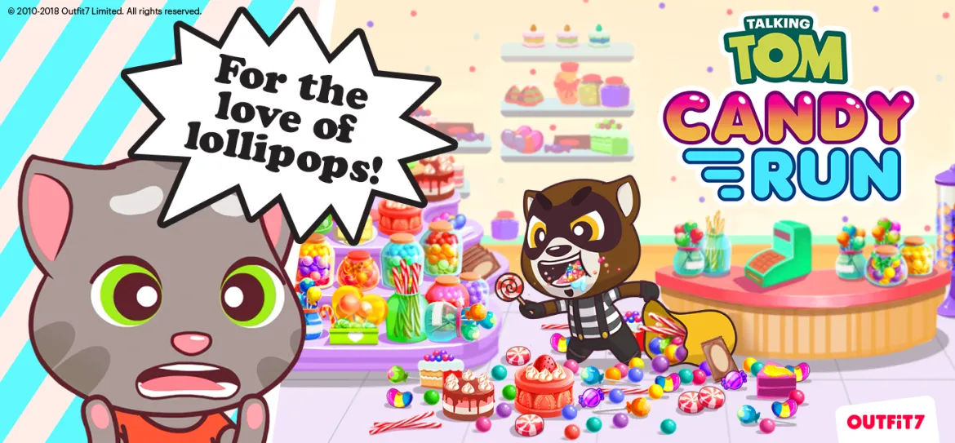

How do you plan to make your game engaging?

When the character collects at least 20 candies then there will be lot of powerups and the player can change the character on 100 candies.